- Copyright for test papers and marking guides remains with West Australian Test Papers.
- The papers may only be reproduced within the purchasing school according to the advertised conditions of sale.
- Test papers must be withdrawn after use and stored securely in the school until 15th June.

CHEMISTRY
UNIT 3
2023

MARKING GUIDE

TIME ALLOWED FOR THIS PAPER

Reading time before commencing work: Ten minutes
Working time for the paper: Three hours

MATERIALS REQUIRED/RECOMMENDED FOR THIS PAPER

To be provided by the supervisor:
This Question/Answer Booklet
Multiple-choice Answer Sheet
Chemistry Data Book

To be provided by the candidate:
Standard items: pens, pencils, eraser or correction fluid, ruler, highlighter.

Special items: calculators satisfying the conditions set by the SCSA for this subject.

IMPORTANT NOTE TO CANDIDATES
No other items may be taken into the examination room. It is your responsibility to ensure that you do not have any unauthorised notes or other items of a non-personal nature in the examination room. If you have any unauthorised material with you, hand it to the supervisor before reading any further.

Structure of this paper

Section | Number of questions available | Number of questions to be answered | Suggested working time  (minutes) | Marks available | Percentage of exam
Section One  Multiple-choice | 25 | 25 | 50 | 25 | 25
Section Two  Short answer | 8 | 8 | 60 | 75 | 35
Section Three  Extended answer | 5 | 5 | 70 | 89 | 40
 |  |  |  | Total | 100

Section One: Multiple-choice 25% (25 marks)

1 | a □ b ■ c □ d □ |  | 6 | a □ b □ c ■ d □ |  | 11 | a ■ b □ c □ d □
2 | a □ b □ c □ d ■ |  | 7 | a □ b ■ c □ d □ |  | 12 | a □ b □ c □ d ■
3 | a □ b ■ c □ d □ |  | 8 | a □ b ■ c □ d □ |  | 13 | a □ b □ c □ d ■
4 | a □ b □ c ■ d □ |  | 9 | a □ b □ c ■ d □ |  | 14 | a □ b □ c ■ d □
5 | a □ b □ c ■ d □ |  | 10 | a ■ b □ c □ d □ |  | 15 | a □ b ■ c □ d □

16 | a □ b □ c □ d ■ |  | 21 | a □ b ■ c □ d □
17 | a □ b ■ c □ d □ |  | 22 | a □ b □ c ■ d □
18 | a □ b □ c ■ d □ |  | 23 | a ■ b □ c □ d □
19 | a □ b □ c □ d ■ |  | 24 | a □ b □ c ■ d □
20 | a □ b ■ c □ d □ |  | 25 | a □ b ■ c □ d □

Section Two: Short answer 35% (75 marks)

Question 26 (11 marks)

(a) On the axes below, sketch an energy profile diagram for this reaction. Label the reactants, products, activation energy and enthalpy change. (3 marks)

Description | Marks
Progress of reaction
Enthalpy (kJ mol⁻¹)
E_{a}
ΔH
H₂(g) + Br₂(g)
2 HBr(g)
Shape of curve is exothermic | 1
Reactants and products labelled | 1
Activation energy and enthalpy change correctly labelled | 1
Total | 3

(b) Explain, in terms of collision theory, how platinum increases the rate of this reaction.
(2 marks)

Description | Marks
A catalyst provides an alternate reaction pathway with a lower activation energy. | 1
This results in a greater proportion of particles with E_{k} > E_{a}. | 1
Total | 2

(c) Complete the tables below by;
- identifying two (2) changes that could be imposed on this system, which would result in a darker red-brown appearance, and
- justifying why this colour change occurs. (6 marks)

Description | Marks
Imposed change 1  - Increase in temperature. | 1
Justification  - The endothermic / reverse reaction would be favoured.  - This would result in an increased concentration of Br₂(g) (and thus result in a darker colour). | 1  1
Imposed change 2  - Decrease in volume. | 1
Justification  - The gas particles would be forced into a smaller space.  - This would result in an increased concentration of Br₂(g) (and thus result in a darker colour). | 1  1
Total | 6

Question 27 (10 marks)

(a) Write an equation for this process that illustrates each the Arrhenius and Bronsted-Lowry behaviours of an acid. (3 marks)

Description | Marks
Arrhenius  HMnO₄(aq) → H⁺(aq) + MnO₄⁻(aq) | 1
Bronsted-Lowry  HMnO₄(aq) + H₂O(l) → H₃O⁺(aq) + MnO₄⁻(aq) | 1
Both equations use a single arrow. | 1
Total | 3
Note: state symbols are not required for full marks.

(b) Demonstrate, with the use of oxidation numbers, that permanganic acid is both the oxidising and reducing agent in this reaction. (2 marks)

Description | Marks
Mn atoms are reduced, oxidation number changes from (+7) to (+4). | 1
O atoms are oxidised, oxidation number changes from (–2) to (0) / (–1). | 1
Total | 2

(c) Explain, in terms of collision theory, how adding heat or other acids can speed up this decomposition reaction. (3 marks)

Description | Marks
Addition of heat  - The average kinetic energy of particles is increased.  - This results in a higher frequency of collisions and a greater proportion of successful collisions. | 1  1
Addition of other acids  - An increased concentration of H⁺(aq) / H₃O⁺(aq) results in a higher frequency of reactant collisions (i.e. between H⁺(aq) and MnO₄⁻(aq)). | 1
Total | 3

(d) What is the likely pH of sodium permanganate solution, NaMnO₄(aq)? Circle your choice below and justify your answer. (2 marks)

Description | Marks
7 (circled) | 1
The conjugate base of a strong acid is neutral.  or  The salt formed from a strong acid and strong base is neutral.  or  Neither Na⁺(aq) or MnO₄⁻(aq) undergo hydrolysis. | 1
Total | 2

Question 28 (9 marks)

(a) Calculate the concentration of hydrochloric acid (in mol L⁻¹) in the freshly prepared aqua regia sample. (6 marks)

Description | Marks
n(NaOH) = 0.1778 x 0.01728  = 0.0030724 mol | 1
n(H⁺ in 15 mL) = 0.0030724 mol | 1
n(H⁺ in 250 mL) = 0.0030724 x (250 / 15)  = 0.0512064 mol | 1
= n(H⁺ in 5 mL of aqua regia) | 1
n(H⁺ from HCl) = (3 / 4) x 0.0512064  = 0.0384048 mol | 1
c(HCl) = 0.0384048 / 0.005  = 7.681 mol L⁻¹ | 1
Total | 6

(b) Describe why the concentration of hydrochloric acid calculated is likely to be lower than that used to prepare the original aqua regia solution. (1 mark)

Description | Marks
As decomposition of aqua regia occurs, the concentration of hydrochloric (and nitric) acid will fall. | 1
Total | 1

(c) Identify two (2) safety risks the chemist should consider when performing this analysis. (2 marks)

Description | Marks
Any two (2) of the following:  - Acids (HCl / HNO₃) are corrosive  - Toxic vapours are produced during the decomposition  - Bases (NaOH) are caustic | 2
Total | 2

Question 29 (9 marks)

(a) Write a balanced ionic equation for the reaction that would occur when 1.0 mol L⁻¹ nitric acid is poured over powdered iron(III) carbonate. Include state symbols in your answer. (3 marks)

Description | Marks
Fe₂(CO₃)₃(s) + 6 H⁺(aq) → 2 Fe³⁺(aq) + 3 CO₂(g) + 3 H₂O(l)
Correct species | 1
Correct balancing | 1
Correct state symbols | 1
Total | 3

(b) Write observations for the reaction that would take place when chlorine gas is bubbled through sodium bromide solution. (2 marks)

Description | Marks
A green-yellow gas dissolves in a colourless solution. | 1
An orange solution is formed. | 1
Total | 2

(c) Write balanced oxidation and reduction half-equations for the reaction that would occur when a several pieces of chromium are placed in a tin(II) nitrate solution. (2 marks)

Description |  | Marks
Oxidation | Cr(s) → Cr³⁺(aq) + 3 e⁻ | 1
Reduction | Sn²⁺(aq) + 2 e⁻ → Sn(s) | 1
Total |  | 2
Note: state symbols are not required for full marks.

(d) Prove whether the reaction below would occur spontaneously, under standard conditions.
(2 marks)

Description | Marks
Fe²⁺(aq) → Fe³⁺(aq) + e⁻ – 0.77 V  O₂(g) + 2 H⁺(aq) + 2 e⁻ → H₂O₂(aq) + 0.70 V | 1
EMF is negative / less than zero / – 0.07 V (therefore reaction would not occur spontaneously). | 1
Total | 2

Question 30 (9 marks)

Complete the table, by stating the effect of each change on the;
- position of equilibrium
- rate of the reverse reaction, and
- concentration of O₂(g).

Description | Marks
Position of equilibrium Rate of reverse reaction Concentration of O₂(g)  Addition of H₂O(g) at constant volume left increased decreased  Removal of NH₃(g) at constant volume left decreased decreased  Decrease total volume of system right increased increased | 9
Total | 9

Question 31 (10 marks)

Calculate the pH of the filtered water sample. You may assume the original pH of the untreated water was 7.

Description | Marks
m(Mn²⁺ in sample) = 0.120 x 455  = 54.6 mg | 1
= 0.0546 g | 1
n(Mn²⁺) = 0.0546 / 54.94  = 0.0009938 mol | 1
n(MnO(OH)₂) = 0.0009938 mol | 1
m(MnO(OH)₂) = 0.0009938 x 104.956  = 0.1043 g | 1
m(Fe(OH)₃) = 0.487 – 0.1043  = 0.3827 g | 1
n(Fe(OH)₃) = 0.3827 / 106.874  = 0.003581 mol | 1
n(H⁺ total) = 2 x n(Fe(OH)₃) + 2 x n(MnO(OH)₂)  = 0.009149 mol | 1
c(H⁺) = 0.009149 / 455  = 2.011 x 10⁻⁵ mol L⁻¹ | 1
pH = – log (2.011 x 10⁻⁵)  = 4.697 | 1
Total | 10

Question 32 (8 marks)

(a) On the equation above, label and link the conjugate acid-base pairs. (2 marks)

Description | Marks
H₂PO₄⁻(aq) + CO₃²⁻(aq) ⇌ HCO₃⁻(aq) + HPO₄²⁻(aq)
acid base acid base

Acidic and basic species correctly labelled | 1
Pairs correctly linked | 1
Total | 2

(b) Identify one (1) solution above that would have a pH below 7, and support your choice with an appropriate chemical equation. (2 marks)

Description | Marks
NaH₂PO₄ | 1
H₂PO₄⁻(aq) + H₂O(l) ⇌ HPO₄²⁻(aq) + H₃O⁺(aq) | 1
Total | 2
Note: state symbols are not required for full marks.

(c) Identify one (1) solution above that would have a pH above 7, and support your choice with an appropriate chemical equation. (2 marks)

Description | Marks
Na₂CO₃  or  NaHCO₃  or  Na₂HPO₄ | 1
CO₃²⁻(aq) + H₂O(l) ⇌ HCO₃⁻(aq) + OH⁻(aq)  or  HCO₃⁻(aq) + H₂O(l) ⇌ H₂CO₃(aq) + OH⁻(aq)  or  HPO₄²⁻(aq) + H₂O(l) ⇌ H₂PO₄⁻(aq) + OH⁻(aq) | 1
Total | 2
Note: state symbols are not required for full marks.

(d) Define the term ‘polyprotic’ and name one (1) different polyprotic acid. (2 marks)

Description | Marks
Donates more than one proton / H⁺ per molecule.  or  Contains more than one acidic / ionisable hydrogen per molecule. | 1
Many possible answers, including;  - sulfuric acid  - sulfurous acid  - oxalic acid | 1
Total | 2

Question 33 (9 marks)

(a) Write balanced half-equations for the reactions occurring at each electrode. (3 marks)

Description |  | Marks
Cathode | Cl₂(g) + 2 e⁻ → 2 Cl⁻(aq) | 1
Anode | Co(s) → Co²⁺(aq) + 2 e⁻ | 1
Half-equations matched to correct electrode |  | 1
Total |  | 3
Note: state symbols are not required for full marks.

(b) Complete the following table. (3 marks)

Description |  | Marks
Concentration of Co²⁺(aq) | 1 mol L⁻¹ | 1
Pressure of Cl₂(g) | 100 kPa or 101.3 kPa | 1
EMF | +1.64 V | 1
Total |  | 3
Note: correct units are required for full marks.

(c) Complete the following table, for this version of the cell. (3 marks)

Description |  | Marks
Polarity of C(s) | positive | 1
Observations at C(s) | colourless (odourless) gas produced | 1
EMF | +0.28 V | 1
Total |  | 3

Section Three: Extended answer 40% (89 marks)

Question 34 (16 marks)

(a) On the axes below, sketch a titration curve for this investigation. Label the equivalence point. (3 marks)

Description | Marks
Volume of HCl(aq)
pH 7 –
← equivalence point
Initial and final pH approximated correctly | 1
Shape of curve sketched correctly | 1
Equivalence point labelled correctly | 1
Total | 3

(b) Calculate the average titre using the professor’s data. (1 mark)

Description | Marks
22.37 mL | 1
Total | 1

(c) Which student obtained the most precise results? Justify your answer. (2 marks)

Description | Marks
Student A | 1
Data set has the smallest range. | 1
Total | 2

(d) Which student used phenolphthalein indicator (end point pH 8.8 - 10.1) in their titration? Justify your answer. (2 marks)

Description | Marks
Student C | 1
A basic end point would occur before the equivalence point, resulting in titres volumes being lower than the true value. | 1
Total | 2

(e) Suggest two (2) sources of random error that may have affected the professor’s results. (2 marks)

Description | Marks
Any two (2) of the following:  - Slight errors in reading glassware volumes  - Judgement of end point colour  - Drops of solution remaining inside pipette / on sides of conical flask  - Small bubbles of air trapped in burette tap | 2
Total | 2

(f) Calculate the concentration of the hydrochloric acid solution, using the professor’s results. State your answer to the appropriate number of significant figures. (6 marks)

Description | Marks
n(Na₂B₄O₇.10H₂O) = 11.06 / 381.38  = 0.02890 mol | 1
c(B₄O₇²⁻) = 0.02890 / 0.5  = 0.0580 mol L⁻¹ | 1
n(B₄O₇²⁻ in 20 mL) = 0.0580 x 0.02  = 0.001160 mol | 1
n(H⁺ total) = 2 x n(B₄O₇²⁻)  = 0.002320 mol | 1
c(H⁺) = 0.002320 / 0.02237  = 0.10371 mol L⁻¹ | 1
= 0.1037 mol L⁻¹ (4 SF) | 1
Total | 6

Question 35 (16 marks)

(a) Prove, using oxidation numbers, that oxygen and water react at the cathodic site. (2 marks)

Description | Marks
O atoms are reduced, oxidation number changes from (0) to (–2). | 1
Reduction always occurs at the cathode. | 1
Total | 2

(b) Explain why aluminium and zinc can be used as sacrificial anodes, but tin cannot. (3 marks)

Description | Marks
Aluminium and zinc have oxidation potentials higher than that of iron / higher than +0.44 V / of +1.68 V and +0.76 V. | 1
This means they will oxidise / corrode preferentially to iron. | 1
Tin has an oxidation potential lower than that of iron / lower than +0.44 V / of +0.14 V (and thus will not provide sacrificial protection). | 1
Total | 3

(c) Write a balanced chemical equation for the redox reaction occurring when an aluminium sacrificial anode is connected to the hot water tank. (2 marks)

Description | Marks
4 Al(s) + 3 O₂(g) + 6 H₂O(l) → 4 Al³⁺(aq) + 12 OH⁻(aq)
or
4 Al(s) + 3 O₂(g) + 6 H₂O(l) → 4 Al(OH)₃(s)
Correct species | 1
Correct balancing | 1
Total | 2
Note: state symbols are not required for full marks.

A 545 g aluminium rod was connected to a hot water tank, to act as the sacrificial anode. It was known that, on average, 261 mL of oxygen gas would react each day.

* If it is preferred not to examine PV=nRT, then ‘261 mL of oxygen gas’ may be replaced with ‘0.347 g of oxygen gas’, and the reference to environmental conditions in part (d) can be removed.

(d) Calculate the number of years the hot water tank would be protected, before the aluminium rod would need replacing. Assume constant environmental conditions of 20.0 °C and 101.3 kPa. (5 marks)

Description | Marks
n(Al) = 545 / 26.98  = 20.2001 mol | 1
n(O₂ consumed) = (3 / 4) x 20.2001  = 15.1501 mol | 1
V(O₂ consumed) = (15.1501 x 8.314 x 293.15) / 101.3  = 364.507 L | 1
Number of days = 364.507 / 0.261  = 1396.6 days | 1
= 1396.6 / 365  = 3.83 years protection | 1
Total | 5
Note: award follow through marks based on incorrectly balanced equation in part (c).

(e) If a sacrificial zinc anode, of the same mass, had been used instead, would this provide longer lasting protection for the hot water tank? Support your answer with appropriate calculations. (4 marks)

Description | Marks
n(Zn) = 545 / 65.38  = 8.3359 mol | 1
n(O₂ consumed) = (1 / 2) x 8.3359  = 4.1679 mol | 1
V(O₂ consumed) = (4.1679 x 8.314 x 293.15) / 101.3  = 100.279 L | 1
Number of days = 100.279 / 0.261  = 384 days | 1
Total | 4
Alternate working:
The final two marks may be awarded for written conclusions, such as;
- A smaller number of moles of O₂ is consumed using an equal mass of Zn
- Therefore the Zn anode would not provide as long lasting protection

Question 36 (20 marks)

(a) Classify these equilibria as ‘homogeneous’ or ‘heterogeneous’, and write the equilibrium constant expression for each. (4 marks)

Description | Marks
Equilibrium 1
Heterogeneous | 1
[Cu²⁺] [OH⁻]²  1  K = | 1
Equilibrium 2
Homogeneous | 1
[Cu²⁺] [NH₃]⁴  [Cu(NH₃)₄²⁺]  K = | 1
Total | 4

(b) Describe any observations that would have been made as equilibrium was established. (2 marks)

Description | Marks
Blue solution fades. | 1
Blue solid forms. | 1
Total | 2

(c) On the graph above, add a curve showing the concentration changes for OH⁻(aq) ions, from Time 0 to E1. Continue your curve from Time E1 to T1. (3 marks)

Description | Marks
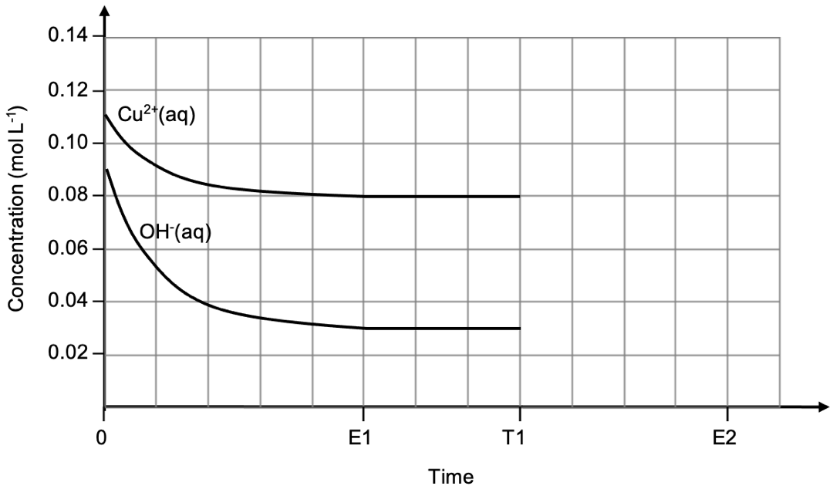
Correct initial (0.09 mol L⁻¹) and final (0.03 mol L⁻¹) concentration of OH⁻(aq) | 1
Correctly sketched shape of curve from Time 0 to E1 | 1
Horizontal from E1 to T1 | 1
Total | 3

(d) Explain why no curve can be plotted for Cu(OH)₂(s). (1 mark)

Description | Marks
Solids do not have a measurable concentration / can be considered to have a fixed concentration. | 1
Total | 1

(e) Explain, in terms of collision theory, what is happening to the rate of the forward reaction from Time 0 to Time E1. (3 marks)

Description | Marks
Concentration of reactant particles / Cu²⁺(aq) and OH⁻(aq) is decreasing. | 1
Thus, less frequent collisions are occurring. | 1
The forward reaction rate is therefore decreasing. | 1
Total | 3

(f) On the same graph above, sketch a curve using a dotted line, showing the change in concentration for NH₃(aq) from Time T1 until equilibrium is established at Time E2. (2 marks)

Description | Marks
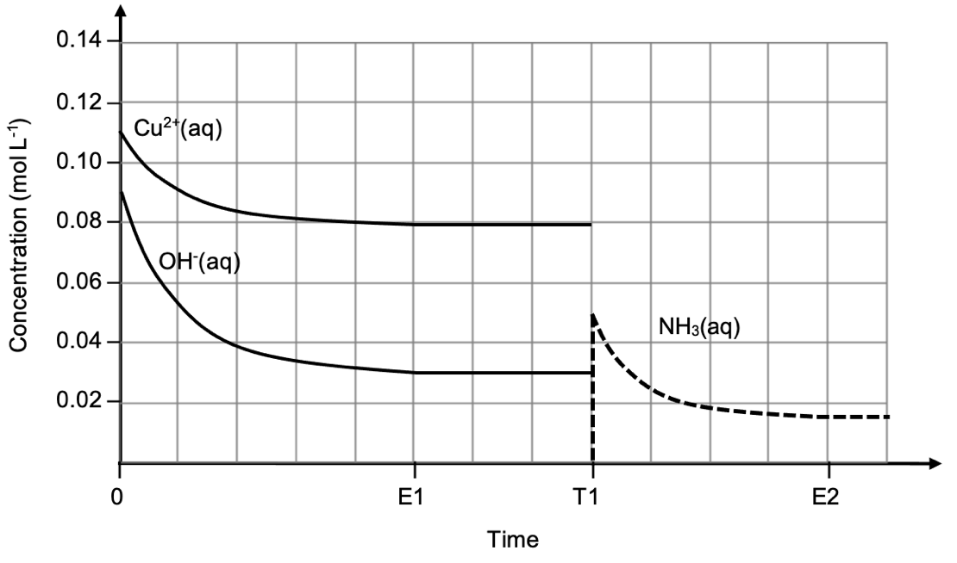
Vertical line at T1 showing addition of NH₃(aq) | 1
Correctly sketched shape of curve from Time T1 to E2 (no particular gradient or estimation of concentration values are necessary) | 1
Total | 2
Note: no particular gradient or estimation of initial / final concentration values are necessary in this question; marks should be allocated for a curve that matches the shape of that above.

(g) Explain this observation, in terms of collision theory and reaction rates. (5 marks)

Description | Marks
Addition of NH₃ decreased the concentration of Cu²⁺(aq) (present in Equilibrium 1). | 1
This resulted in a decrease in the frequency of reactant collisions. | 1
The forward and reverse reaction rates were both decreased, but the forward rate decreased by more.  or  The forward and reverse reaction rates were both decreased, but the reverse rate decreased by less.  or  Therefore the reverse reaction rate was occurring faster than the forward reaction rate. | 1
This resulted in the reverse reaction being favoured.  or  This resulted in a shift to the left. | 1
Thus Cu(OH)₂(s) was consumed (decreasing the mass present). | 1
Total | 5

Question 37 (19 marks)

(a) Write a series of two (2) balanced chemical equations, showing how the production of CO₂(aq) by the fish, results in a lowered water pH. (2 marks)

Description |  | Marks
1. | CO₂(aq) + H₂O(l) ⇌ H₂CO₃(aq) | 1
2. | H₂CO₃(aq) + H₂O(l) ⇌ H₃O⁺(aq) + HCO₃⁻(aq)  or  H₂CO₃(aq) ⇌ H⁺(aq) + HCO₃⁻(aq) | 1
Total |  | 2
Note: state symbols are not required for full marks.

(b) Describe how this results in the formation of an ‘open system’. (2 marks)

Description | Marks
In an open system matter and energy can be exchanged. | 1
(Opening the bag results in) CO₂(g) is able to leave the system / air is able to enter the system. | 1
Total | 2

(c) Write a chemical equation showing how CaCO₃(s) can result in an increased water pH. (2 marks)

Description | Marks
CO₃²⁻(aq) + H₂O(l) ⇌ HCO₃⁻(aq) + OH⁻(aq)
or
CaCO₃(s) + 2 H⁺(aq) → Ca²⁺(aq) + CO₂(aq) + H₂O(l)
or
CaCO₃(s) + 2 H₃O⁺(aq) → Ca²⁺(aq) + CO₂(aq) + 3 H₂O(l)
Correct species | 1
Correct balancing | 1
Total | 2
Note: state symbols are not required for full marks.

(d) Explain how this buffer allows the pH of aquarium water to be maintained, as acids are produced. Use a chemical equation to support your answer. (4 marks)

Description | Marks
Production of acids will increase the concentration of H₃O⁺(aq). | 1
This will react with the conjugate base component / CO₃²⁻(aq) in the buffer. | 1
H₃O⁺(aq) + CO₃²⁻(aq) ⇌ HCO₃⁻(aq) + H₂O(l) | 1
The concentration of H₃O⁺(aq) is thus relatively unaltered, maintaining pH. | 1
Total | 4

(e) Write balanced half-equations, in acidic conditions, representing both processes performed by the nitrifying bacteria. (4 marks)

Description |  | Marks
Ammonia to nitrite ions | NH₃(aq) + 2 H₂O(l) → NO₂⁻(aq) + 7 H⁺(aq) + 6 e⁻ | 2
Nitrite ions to nitrate ions | NO₂⁻(aq) + H₂O(l) → NO₃⁻(aq) + 2 H⁺(aq) + 2 e⁻ | 2
Total |  | 4
Note: state symbols are not required for full marks.

(f) Describe how the student could prepare a full tank of water with a pH of 8.6. Support your answer with appropriate calculations. (5 marks)

Description | Marks
[H⁺ desired] = 10^{-8.6}  = 2.5119 x 10⁻⁹ mol L⁻¹ | 1
[OH⁻ desired] = (1.0 x 10⁻¹⁴) / (2.5119 x 10⁻⁹)  = 3.9811 x 10⁻⁶ mol L⁻¹ | 1
n(OH⁻ required) = 3.9811 x 10⁻⁶ x 75  = 2.9858 x 10⁻⁴ mol | 1
V(NaOH required) = 2.9858 x 10⁻⁴ / 0.02717  = 0.01099 L | 1
Place 11 mL of NaOH in the tank, and make up to 75 L with distilled water. | 1
Total | 5
Alternate working for final two steps of calculation:
V(NaOH required) = c₂V₂ / c₁
= (3.9811 x 10⁻⁶ x 75) / 0.02717
= 0.01099 L

Question 38 (18 marks)

(a) What is ‘metal electroplating’? (1 mark)

Description | Marks
Applying a metal coating to an object by electrolytic means. | 1
Total | 1

(b) Suggest two (2) reasons that it may be desirable to plate objects with nickel. (2 marks)

Description | Marks
Any two (2) of the following:  - Appearance / aesthetics / decoration  - Prevent corrosion  - Increase thickness / size of object  - Increase abrasion resistance / resistance to wear and tear | 2
Total | 2

(c) Why is a power source required for the electroplating process? (1 mark)

Description | Marks
To force the non-spontaneous reaction to occur. | 1
Total | 1

(d) On the diagram above, label the polarity (sign) of the electrodes. (1 mark)

Description | Marks
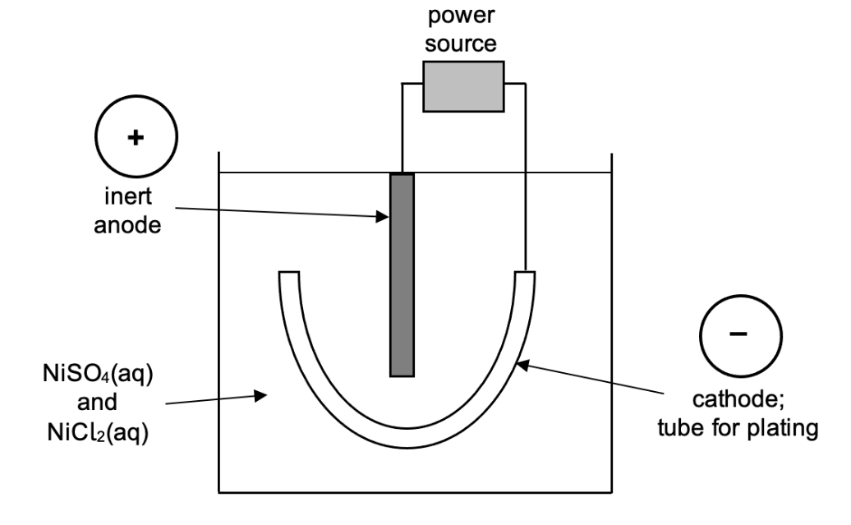
Signs allocated correctly | 1
Total | 1

(e) Explain why cations migrate towards the cathode in an electroplating cell. (2 marks)

Description | Marks
Electrons move towards the cathode creating a negative charge / potential. | 1
Thus the oppositely charged cations are (electrostatically) attracted. | 1
Total | 2

(f) Write half-equations representing the reactions occurring at the cathode and anode in this cell. (4 marks)

Description | Marks
Cathode
Ni²⁺(aq) + 2 e⁻ → Ni(s)
Correct species | 1
Correct balancing | 1
Anode
2 H₂O(l) → O₂(g) + 4 H⁺(aq) + 4 e⁻
Correct species | 1
Correct balancing | 1
Total | 4
Note: state symbols are not required for full marks.

(g) List two (2) observations that would be made as this cell operates. (2 marks)

Description | Marks
Any two (2) of the following:  - Green solution fades  - Silver solid forms on tube / cathode  - Colourless (odourless) gas produced at anode | 2
Total | 2

(h) Calculate the number of tubes that could be plated with nickel, before the electrolyte would need to be replenished. (5 marks)

Description | Marks
n(NiSO₄) = 1.14 x 1050  = 1197 mol | 1
n(NiCl₂) = 0.337 x 1050  = 353.85 mol | 1
n(Ni²⁺ total) = 1550.85 mol | 1
m(Ni²⁺ total) = 1550.85 x 58.69  = 91019 g | 1
Number of tubes = 91019 / 41.2  = 2209 | 1
Total | 5

